Abdul Moiz

Assignment

Client and Server

Client:

Used in home and corporate networks, a client is any computer hardware or software device that requests access to a service provided by a server. Clients are typically seen as the requesting program. Client end-user devices typically include desktop computers, laptops and smartphones.

Server:

A client process may run on the same device. It can also connect over a network to a server to run on a different device. Examples of servers may include database servers, mail servers, print servers, file servers, web servers, application servers, and game servers.

How client interact with server:

In a client-server architecture, clients interact with servers by making requests for data or resources that the client is not capable of providing. Clients and servers can be located in different areas and connect via a network

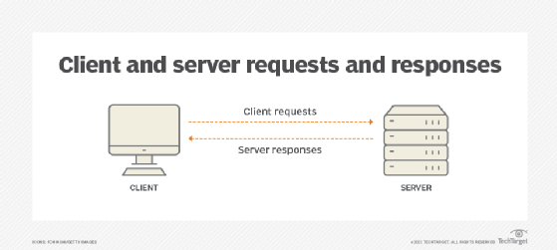

Client side VS Server Side:

The client-side is an action or operation that occurs on the user's side, while server-side refers to actions or operations that occur on a server

Github:

Github is a web-based interface that uses Git the open source version control software that lets multiple people make separate changes to web pages at the same time. As Carpenter notes, because it allows for real-time collaboration, GitHub encourages teams to work together to build and edit their site content.

* **Git** — a tool that allows developers and others to use version control
* **GitHub** — one of many web interfaces for using Git